Intuition – Predict whether the new data point will fall into the either of the category

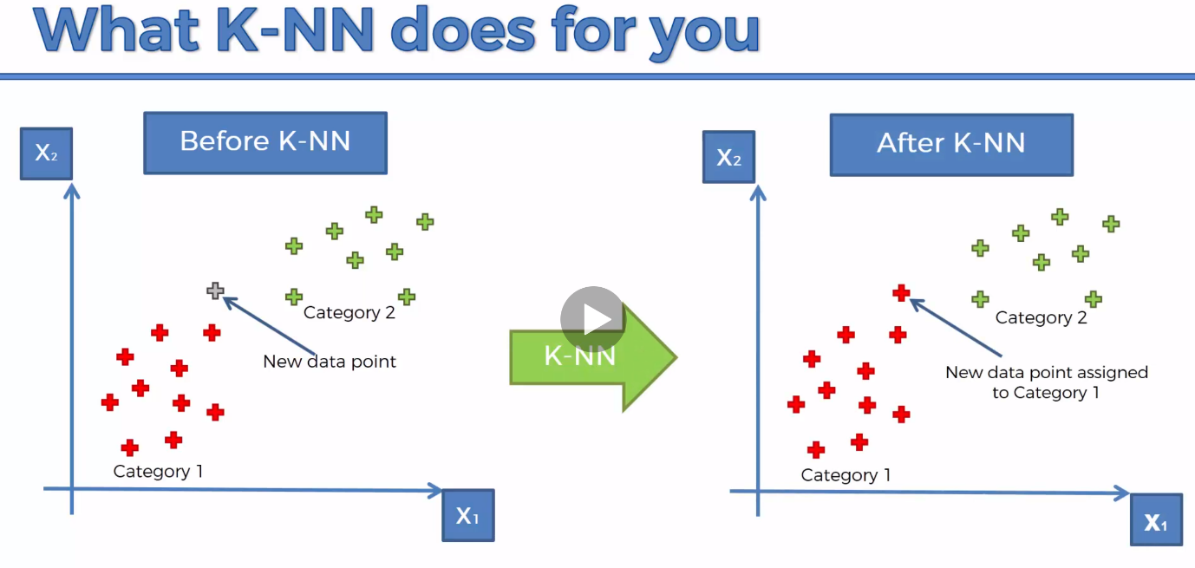Steps:

1. Choose the number of K of neighbours (Default = 5)
2. Take the K nearest neighbours of the new data point, according to the Eculidean Distance
3. Among these K neighbours, count the number of data points in each category
4. 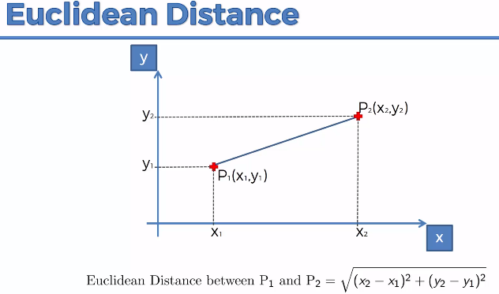Assign the new data point to the category where you counted the most neighbours

